META - Investment Analysis

Talon Hird, December 8th 2024, Acctg 432

1. Buy/Sell/Hold

Meta’s qualitative and quantitative factors aggregate into a ***hold*** rating for its stock. While Meta has shown strong revenue growth, attractive financials, and huge upside potential for its Reality Labs Segment and Metaverse research, there is enough risk to warrant caution. This risk is largely in the form of increasing regulatory scrutiny around customer data collection which poses threat to its near monopolistic position over social media and proprietary algorithms (which addict you and make sure you can’t get off instagram).

While 2025 projects to be an outstanding year for revenue growth based on a 0.92 r^2 PPE vs Revenue regression, I have Meta’s revenue tapering down to an 8.5% growth rate as the company continues to mature through 2030. The CI margin is set as a historical average of 32.6% as well as the distribution ratio being an average of 46.3%. I set the value as the market cap at time of analysis and backed out a discount rate higher than what most analysts expect. This indicates my evaluation of the company yields a higher expectation of risk than others. This aligns with my view of regulatory scrutiny posing a large problem in coming years.

1. Estimates
2. Based on the first 3 quarters of available data for 2024 (which have been very strong for Meta), the 2024 ending book value projects to be 169B up from 153B at the end of 2023. A regression showed that PPE in year T-1 can be a reliable predictor of subsequent year revenue. This is likely due to internal growth expectations within the firm manifesting in a capital spending/asset growth policy that ensures they have sufficient data centres and computing power to keep up with the demand for online activity on their platforms. This regression showed an r^2 of 92% and predicts 194B of revenue for 2025. Using recent margins trends we can extrapolate a 64B total comprehensive income for 2025 as well.
3. Long-term growth rate

A firm cannot grow faster than the economy indefinitely so 3% as an eventual long-term growth rate is reasonable. It is unlikely to exceed this by much unless there is a fundamental shift in economic growth paradigms. However, it is unlikely that Meta slows to that for decades so 5% would work better mathematically for the valuation. These come with an assumption that Meta changes its distribution policies to distribute more and reinvest less as it eventually matures and runs out of +NPV projects to invest in.

1. Long-term ROE

The residual income forecast brought the ROE down from current levels of ~ 48% down to 28% by 2030. This indicates extremely strong return prospects. A reasonable long run ROE extrapolated even further would be 20-25%.

1. Discount Rate

The discount rate required to discount the residual incomes in the forecast ended up around 11.4%. This is higher than the average of the analyst expectations I surveyed of about 8.5%. This indicates that perhaps analysts are more bullish than warranted. The higher rate better reflects risks from regulatory uncertainty and the substantial ongoing investment in unproven metaverse technology.

3. Bankruptcy Risk

Meta is at very low risk of bankruptcy. Throughout their recent lifetime, they have not ventured anywhere close to an Altman Z score that would indicate trouble. Their robust financial health has resulted in scores ranging from 17.39 down to a low of 5.08 during their rebranding which tested investor confidence. The X4 component has remained one of their strongest indicators in normal years having soared as high as 25. It also, however, took the brunt of the damage during their rebranding indicating a high degree of investor uncertainty with regard to future cashflows/income. The indicator has since recovered very well.

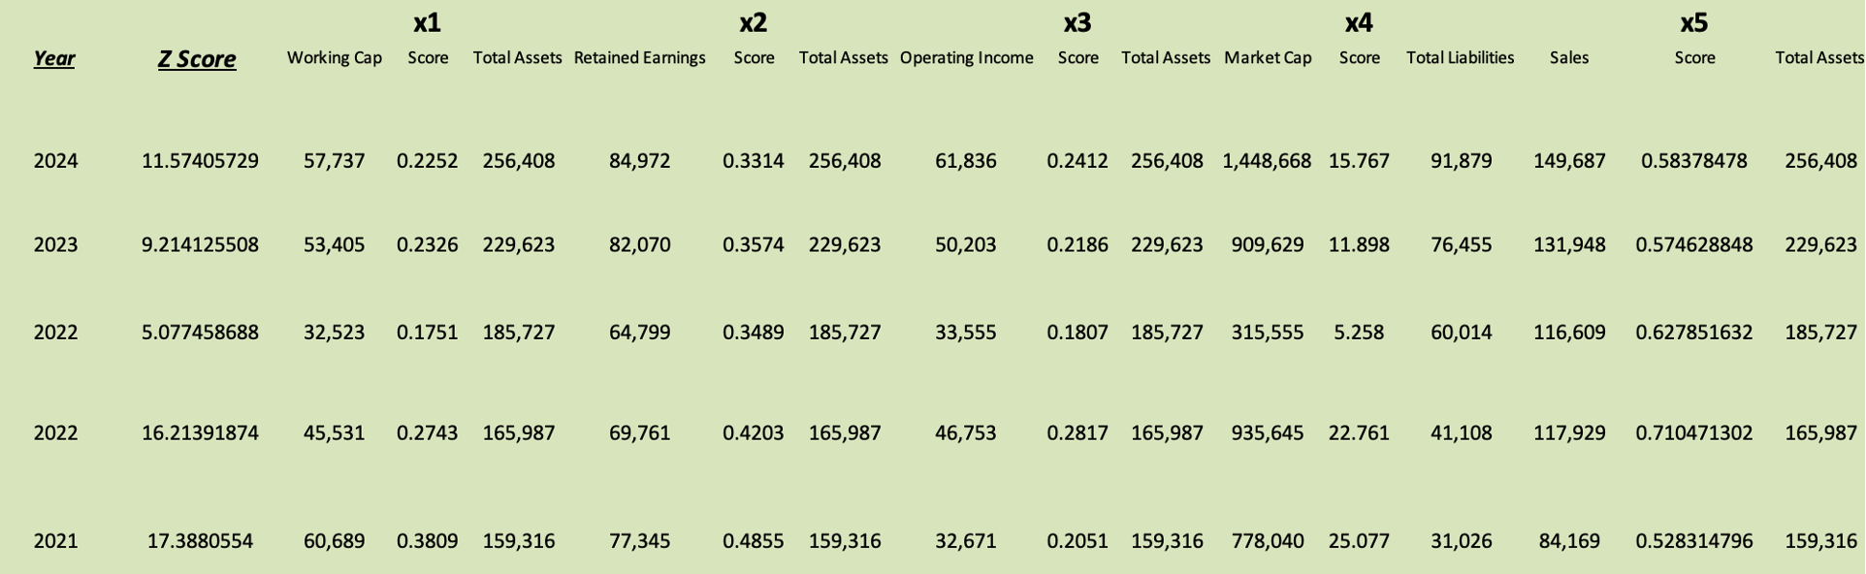

4. Dupont Analysis

Performing a dupont analysis yields a compelling growth narrative for Meta. Their ROE has been increasing quickly since their 2022 (rebranding year) low of 18.5% up to 32.6% in 2024. This has been primarily driven by increasing profit margin expanding at a similar rate. Asset turnover has remained relatively stable averaging in the high 50%’s but, recently has been trending downward likely due to investment in data centres growing their assets at a blistering pace. Total leverage has grown slowly over time from 1.16 in 2018 to 1.56 now. Overall the firm displays impressive ratios and appears to be not only recovering well from their 2022 rebranding, but thriving. 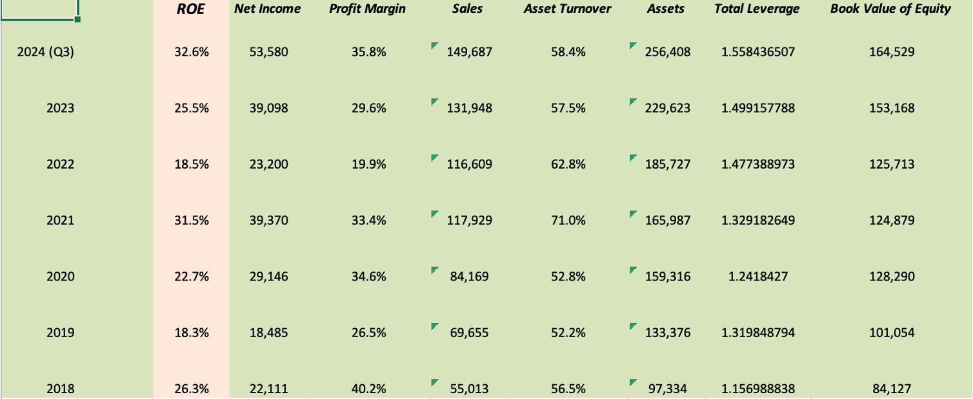

5. Accounting Quality

Regression shows high revenue reliability with r^2 of 97% and very high statistical significance. Operating cashflows is consistently higher than income with the difference averaging about 11% of assets. This relationship does not have an upward or downward trend over time which indicates sound accounting despite the >5% figure. The consistently higher operating cash flow primarily reflects substantial non-cash expenses from stock compensation and data center depreciation, rather than concerning accounting practices. The consistently higher operating cash flow reflects two major and growing non-cash expenses, share based compensation ($16-17B annually) and depreciation ($14-15B annually). 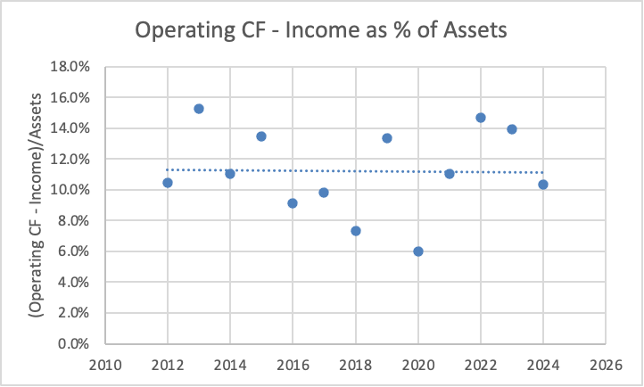

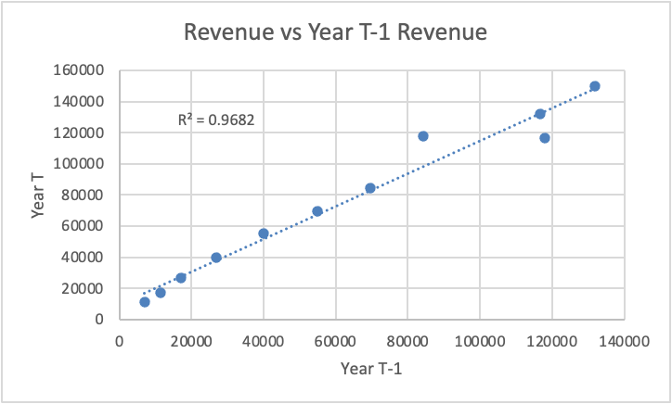

6. Company Segments

One of the most important components of Meta’s narrative is their 2022 rebranding from Facebook to Meta. This indicates an increasing focus on futuristic technology and a vision of the future by Zuckerberg. The vast majority (>98%) of firm revenue was from their family of social media apps. Some of these funds have been used to subsidize R&D losses for the Reality Labs segment that has so far failed to fund itself through sales of AR/VR technology such as Meta Quest VR goggles. This segment represents great ambition and opportunity by Meta to one day be the steward of the Metaverse and reap whatever financial gain comes with that position if it comes to fruition. The expenditures incurred to restructure combined with the stark rebranding caused a brief loss of investor confidence that caused share price to draw down more than 70% in 2021-2022.